**Assignment 8.1**

**Problem Statement:**

Petrol Data Analysis

1. Write a mapreduce program to find the total amount of petrol in volume sold by every distributor.

2. Write a mapreduce program to find which are the top 10 distributors ID's for selling petrol and also display the amount of petrol sold in volume.

**Input:**

Dataset Link:

[**https://github.com/prateekATacadgild/mAPrEDuce/commit/7f78340c5d59d22940587bb76bec94dd4781265f**](https://github.com/prateekATacadgild/mAPrEDuce/commit/7f78340c5d59d22940587bb76bec94dd4781265f)

**Problem 1:**

Write a mapreduce program to find the total amount of petrol in volume sold by every distributor.

**Program:**

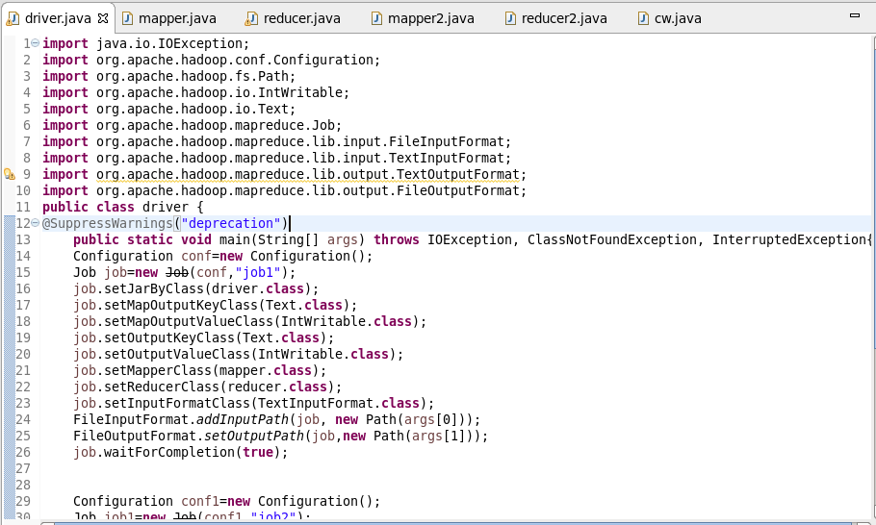

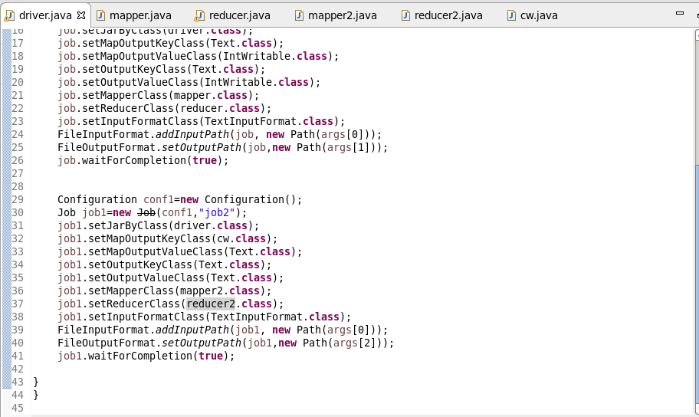

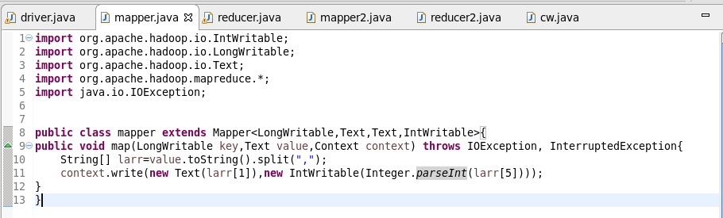

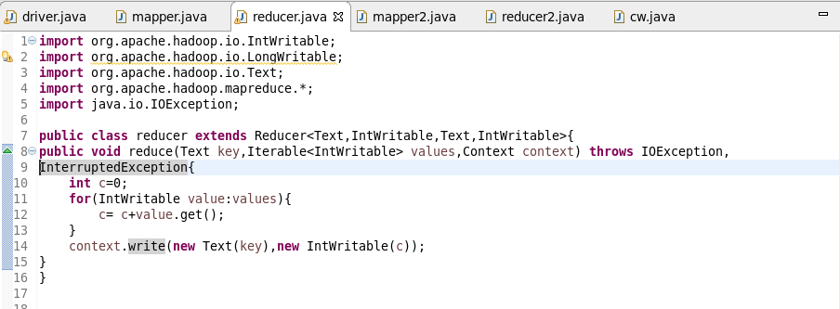

**Problem 2:**

Write a mapreduce program to find which are the top 10 distributors ID's for selling petrol and also display the amount of petrol sold in volume.

**Program:**

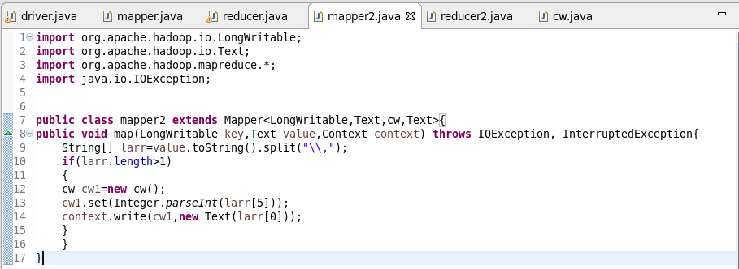

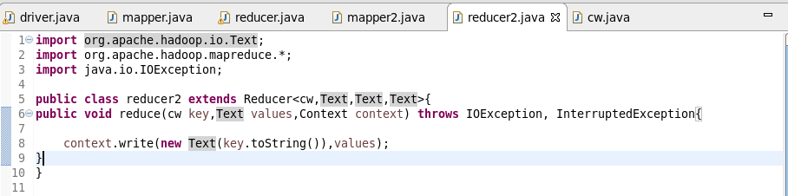

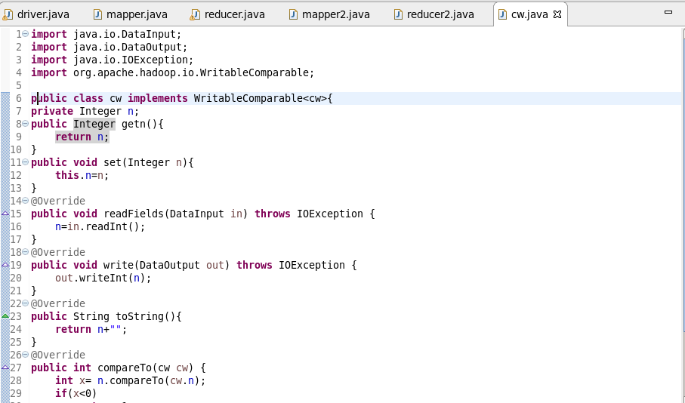

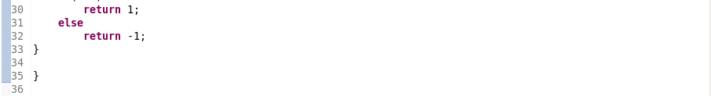

**Output:**

